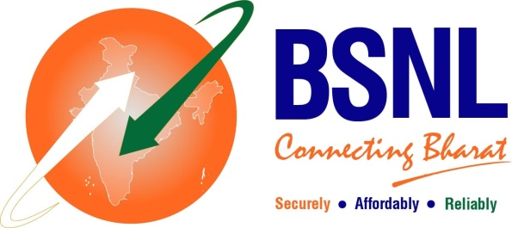

**BSNL CHENNAI TELEPHONES**

*( BSNLCO-CFAO/11(13)/2/2020-CFA dtd 07/08/2024)*

**VIDHYA MITRAM SCHEME**

BSNL is happy to introduce **Vidhya Mitram** **Scheme** for Benevolent Individuals and Institutions to support needy students, as a motivation and a social responsibility. According to this scheme, benevolent individuals and Institutions can sponsor BSNL FTTH connection for under-privileged school and college students. The beneficiary gets to enjoy an **Annual subscription of Bharat Fibre Plan**, ‘**Fibre Entry @ Rs. 329’**.

There are three schemes depending on the number of beneficiaries:

|  |  |  |  |
| --- | --- | --- | --- |
| S No. | Sponsor Scheme | No. Beneficiary students | Annual charges excluding GST to be collected in advance from sponsor |
| 1 | ***Scheme 1*** | 3 | Rs. 11000 |
| 2 | ***Scheme 2*** | 6 | Rs. 21000 |
| 3 | ***Scheme 3*** | 10 | Rs. 35000 |

The scheme has been introduced for a short period and Individuals and Institutions are requested to use this opportunity to support needy and exceptional students.

Thank you for your support and solidarity for a noble cause.

Interested sponsors can reach out to us on *smcfachennai@gmail.com.*